|  |  |  |  |  |
| --- | --- | --- | --- | --- |
| Decorative | | | | |
|  |  |  | |  |
| Goldin Account Manager  Functional Specification | | |
| Goldin Baloyi | | baloyi.jabu@gmail.com |

Contents

Introduction 3

Architectures and Flows 4

Authentication architecture 4

Application Architecture 4

Authentication flow 5

Create account workflow. 6

6

Credit account workflow 7

Debit account workflow 8

8

Conclusion 9

|  |  |  |  |  |
| --- | --- | --- | --- | --- |
| Decorative | | | | |
|  |  |  | |  | |
|  | Introduction  This document contains all the information needed to use the Goldin Account Manager API. The API uses JWT Authentication in order to access all account and transactional account details. This application uses a separate database to store the identity information and also uses an in memory database for account and transactional details. There’s also a Redis cache database which temporarily stores and syncs all accounts and transactions stores in the database for fast retrievals. | |  | |

|  |  |
| --- | --- |
|  |  |
| Architectures and FlowsAuthentication architecture   The token expires after an hour an need to re-login in order to get a new session token. Application Architecture Easily Use Redis Cache In ASP.NET 6.0 Web API    This approach limits the number of times on which the MS SQL database is queried, the Redis storage can handle a lot of requests. | |

## Authentication flow

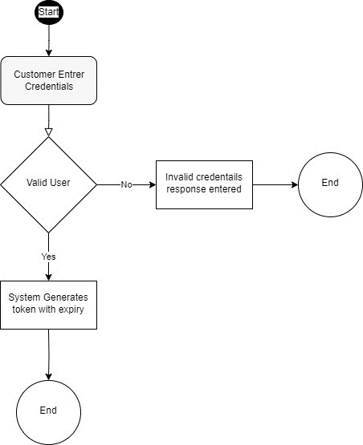

## Create account workflow.

## 

## Credit account workflow

## Debit account workflow

## 

|  |  |  |  |  |
| --- | --- | --- | --- | --- |
|  | |  | | |
| Conclusion There are a lot of ways to manage accounts in a real-world environment, this is just a prototype only to be used for demonstration purposes. No loss or injury obtained with the use of this application can be associated with the developer. Use at your own risk. | | | | |
|  |  | |  | |
| Reliable  This is a .net 7 application which is very reliable and also uses asynchronous programs with very limited bugs | Secure  With JWT tokens, the application is very secure | | High Performance  With the aid of Redis, this application can handle a very high transaction environment | |
|  | |  | |